**Western Interconnection**

**Regional Advisory Body**

**2023 Business Plan and Budget**

**Under Consideration by**

**Appointed Members of the**

**Western Interconnection Regional Advisory Body**

**1600 Broadway, Suite 1720**

**Denver, Colorado 80202**

**720-897-4600**

**Table of Contents**

Introduction… 3

Organizational Overview 5

Membership and Governance 6

Statutory Functional Scope 8

2023 Strategic Priorities and Initiatives 8

2023 Budget and Assessment Impacts 16

Section A – Statutory Activities 20

Governance and Strategic Planning… 21

Emerging Trends and System Risks 21

Periodic Reliability Assessments 24

Reliability Standards and Proactive Enforcement 24

Section B – Supplemental Financial Information 27

Working Capital Reserve 27

Budget Projections for 2022-2024… 29

Section C – Non-Statutory Activities 31

Section D – Additional Consolidated Financial Statements 32

Statement of Financial Position… 32

Appendix A – Organizational Chart 33

# Introduction

The Western Interconnection Regional Advisory Body (WIRAB) proposed budget for 2023 is $890,820. This amount is $28,080 (3.1%) lower than the amount in WIRAB’s approved 2022 budget. Total proposed full-time equivalents (FTEs) for 2023 have remained flat with no change at 3.0. WIRAB’s total funding requirement is $686,120. As shown in Table 1 below, this amount represents the total statutory expenses of $890,820 less $204,700 in statutory working capital requirement. WIRAB’s proposed funding assessment is $685,120, a decrease of $13,580 from the 2022 funding assessment. WIRAB proposes to allocate the funding assessment as follows: $585,414 (85.4%) to the U.S. portion; and $99,706 (14.6%) to the Canadian portion of the Western Interconnection. The following table summarizes the WIRAB proposed budget for 2023.

# Table 1. WIRAB Budget for 2023[1]

# 

# Organizational Overview

The Federal Energy Regulatory Commission (FERC or Commission) created WIRAB in April 2006, upon petition of ten Western Governors and in accordance with Section 215(j) of the Federal Power Act (FPA). The Governors invited all U.S. states, Canadian provinces, and Mexican jurisdictions with territory in the Western Interconnection to join WIRAB and to participate in WIRAB’s activities as a regional advisory body charged with advising the FERC, the North American Electric Reliability Corporation (NERC) and the Regional Entity (i.e., the Western Electricity Coordinating Council or WECC) on matters of electric grid reliability.

In July 2006, the FERC issued an order granting the Governors’ petition to establish WIRAB.[2] In its order, the FERC determined that WIRAB should receive funding for its Section 215(j) activities and directed WIRAB to annually develop a budget and related information for submittal through the Electric Reliability Organization (ERO) budget approval process. The Commission instructed WIRAB to develop a budget in a form similar to that specified for regional entities as set forth in Order 672.[3] The FERC also required WIRAB to identify the portion of its funding to be received from Canada and Mexico.

The Governors created WIRAB as a standing advisory committee to the Western Interstate Nuclear Board (WINB), which was formed pursuant to the Western Interstate Nuclear Compact,

P.L. 91-461. WIRAB has the same status under the compact as the Western Interstate Energy Board (WIEB). Below is a chart that illustrates these organizational relationships.

# 

# Figure 1. Organizational Relationships

North American Electric Reliability Corporation

**Western Interstate**

**Energy Board (WIEB)**

* Governors of AZ, CA, CO, ID, MT, NV, NM, OR, UT, WA, WY, and Premiers from AB and BC may appoint member representatives.
* <http://westernenergyboard.org/>

Western Electricity Coordinating Council

**Western Interconnection Regional Advisory Body (WIRAB)**

* Created by FERC pursuant to Section 215(j) of the Federal Power Act.
* Governors / Premiers from AB, AZ, BC, CA, CO, ID, MT, NE, NV, NM, OR, SD, UT, TX, WA, WY and Mexico may appoint member representatives.
* <http://westernenergyboard.org/wirab/>

**Western Interstate Nuclear Board (WINB)**

Established by interstate compact ratified by P.L. 91-461; members appointed by Governors of signatory states

Federal Energy Regulatory Commission

# Membership and Governance

All U.S. states with territory in the Western Interconnection (AZ, CA, CO, ID, MT, NE, NV, NM, OR, SD, TX, UT, WA, WY), the Canadian provinces of Alberta and British Columbia, and the Mexican state of Baja California are eligible to appoint members to WIRAB. Member representatives of WIRAB are appointees of the respective Governors and Premiers, or representative-designated alternates. Below is the list of current WIRAB member representatives:

# Figure 2. WIRAB Membership List

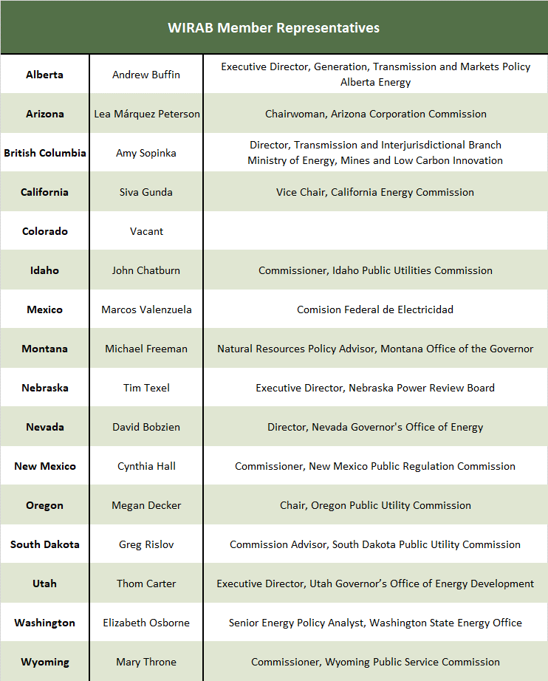

WIRAB holds two in-person meetings each year, usually in Spring and Fall. These meetings are open to the public. WIRAB also holds monthly conference calls to discuss current and emerging issues and hosts periodic webinars with presentations from subject matter experts on key electric grid reliability topics.

# Statutory Functional Scope

The FERC established WIRAB as a Regional Advisory Body under section 215(j) of the FPA. The language in Section 215(j) specifically provides for WIRAB’s authority to advise the FERC, NERC, and WECC on whether reliability standards, budgets and fees, governance, compliance, assessments, strategic direction, and other activities conducted pursuant to Section 215 are just, reasonable, not unduly discriminatory, or preferential, and in the public interest.

WIRAB’s advice to the FERC, NERC, and WECC can be grouped into four categories that are appropriately funded under Section 215 of the FPA, including:

1. Governance and Strategic Planning;
2. Emerging Trends and System Risks;
3. Periodic Reliability Assessments; and
4. Reliability Standards and Proactive Enforcement.

WIRAB’s activities in each of these categories are described in Section A – Statutory Activities.

**2023 Strategic** **Initiatives**

The resource mix of the Western power system is rapidly changing. Environmental policy and regulatory efforts in many states to transition to a lower-carbon economy, plus shifting market forces, have resulted in the retirement of a significant amount of coal-fired, natural gas-fired, and nuclear-powered electricity generation. Utility-scale wind and solar electricity generation are replacing traditional thermal resources throughout the West. California and the Desert Southwest are experiencing rapid growth in distributed solar photovoltaic generation. Energy storage procurement is becoming paramount to support higher penetrations of weather-dependent variable energy resources (VER). New and promising carbon-free technologies like advanced nuclear reactors and hydrogen are emerging to fill the gap created by VERs as the electric system in the West continues to decarbonize.These changes to the generation resource mix may present reliability challenges in the Western Interconnection, but the West has the opportunity to lead in the effort to create a reliable decarbonized electric grid. Flexibility on both the supply-side and demand-side will be needed to ensure reliability.

Reliability challenges associated with climate change are becoming more evident, with widespread heat waves and extreme cold weather making utility planning and operations more difficult. Wildfires and droughts have become more severe, impacting communities and utility infrastructure. Many energy policymakers and regulators are increasingly incorporating environmental and climate change factors into grid infrastructure decisions. With these changes, a renewed focus on grid reliability must be front and center as the grid transforms to meet grid users’ current and future needs throughout the Western Interconnection.

Grid modernization efforts also present reliability challenges and opportunities for the Western Interconnection. Efforts to increase electrification of energy end uses, such as transportation and buildings, plus the increased adoption of distributed energy resources (DER), create a need for better coordination among Bulk Power System (BPS) and distribution system operators. Improvements to coordination will require additional research, development, and the implementation of new technologies and operational tools that can be used to improve system reliability throughout the Western Interconnection. Grid modernization also necessitates an increased focus on cyber security while maintaining the physical protection of electric grid infrastructure against threats like wildfires and other physical impacts. Physical and cyber threats to the grid will continue to impact data availability and transparency, creating a need to ensure the security of data to improve situational awareness.

The structure of Western power markets also continues to undergo significant change, creating both additional reliability challenges and opportunities for the Western Interconnection. The California Independent System Operator (CAISO) Western Energy Imbalance Market (WEIM) continues to gain new participants, and the CAISO is working to offer day-ahead market services to WEIM participants (Extended Day-Ahead Market, or EDAM). The Southwest Power Pool (SPP) also offers market services, including Western Energy Imbalance Services (WEIS), to entities within the Western Interconnection with expanding services through its Markets+ initiative. Some western utilities are also exploring joining SPP’s Regional Transmission Organization (RTO). These market reforms could result in significant changes to system operations (e.g., transmission scheduling, congestion management, and reliability coordination).

In response to these ongoing changes in the Western Interconnection, WIRAB has identified three strategic initiatives that it will pursue in 2023:

Initiative 1: Advise WECC to track generation resource construction and compare it to the resource additions in the Western Assessment of Resource Adequacy to serve as an early warning system of reliability and accountability throughout the Western Interconnection.

The Western Assessment of Resource Adequacy serves as an integral part of the planning process to maintain resource adequacy throughout the Western Interconnection over the next ten years. WECC has encouraged efforts to mitigate resource adequacy risks and has recommended the use of an energy-based probabilistic approach and regular calibration of the Planning Reserve Margins (PRMs) to account for the increasing demand and resource variability throughout the Western Interconnection and ensure greater generation reliability over the next decade. As entities across the West retire old generation resources such as coal-fired power plants, new resource additions must be planned and constructed in a deliberate manner to remain within the PRMs. In the current approach to resource adequacy, there is no accountability system to determine the progress of generation resource construction and how it compares to the resource additions in the Western Assessment of Resource Adequacy.

As the Regional Entity for the Western Interconnection, WECC has an opportunity to act as an early warning system and alert regional entities when they are falling short. Tracking generation resource construction and comparing it to the resource additions in the Western Assessment of Resource Adequacy is necessary to continue the mitigation of resource adequacy risks. In this tracking process, WECC also has the opportunity to identify shortcomings in generation resource construction or ensure resource build-out remains on track. If WECC tracks construction and identifies that the system is not on track, WECC may investigate and identify the issues causing the deterrent, such as supply chain issues, lack of expert labor contractors, or regulatory barriers. The delay in generation resource construction from potential complications may remain unknown in the current approach until it is too late to address and will harm the ability to stay within the PRMs. WECC should begin to monitor resource generation construction and compare these efforts to the resource additions in the Western Assessment of Resource Adequacy for better reliability and accountability throughout the Western Interconnection.

The goals of this initiative are to:

* Ensure planned generation resource construction moves efficiently and according to resource additions in the Western Assessment of Resource Adequacy.
* Identify risk of delay in generation resource construction as soon as possible/practicable and alert regional entities of challenges to resource addition plan and the mitigation of resource adequacy risks across the Western Interconnection.

The actions that WIRAB staff will take to achieve these goals will be to:

* Engage with regional entities, utilities, industry news, and other resources across the Western Interconnection to gather data on construction and megawatts installed and monitor generation resource construction.
* Work with WECC to compare generation resource construction to resource additions in the Western Assessment of Resource Adequacy and determine if the Western Interconnection is falling behind or remaining on track.
* If sub-regions in the Western Interconnection are falling short, WIRAB staff may work with WECC to identify challenges to generation resource construction.
* Participate in WECC activities designed to further these goals.

**Initiative 2: Advise WECC to coordinate and gather historical climate data to understand the climate characteristics in the West and how the information impacts the assumptions in the system reliability assessments and planning models of the Western Interconnection.**

The climate landscape in the Western Interconnection is changing along with the global climate change, which is causing impacts on the operational conditions of the electric system. Historically, peak demand occurred during hot summer days in the southern parts of the western states. The northern parts see peak demands during cold winter days, but that assumption may be shifting. Therefore, the temperature is one of the dominant factors for load forecasting and supply planning. Hydroelectric power accounts for nearly 27 percent of its total capacity in the Western Interconnection. Variable wind and solar resources account for 9.7 percent and 7.7 percent, respectively, with expected significant growth over the next 5-10 years. This weather-dependent resource mix showcases that the level of precipitation can play a key role in deciding the amount of electricity generation supply in the Western Interconnection. The rainfall and snowpack directly affect hydro capacity and wind and solar output. There has been a notion and also corresponding studies that indicate climate change is now altering the patterns of temperature, precipitation, and other factors in the western states and provinces. The changing weather patterns could bring about potential weather-driven reliability risks.

The rigorous study of the changing trends is timely and essential for WECC to understand the impacts these changes have on its reliability assessments. By analyzing a comprehensive dataset related to the temperature and precipitation in the Western Interconnection, WECC can verify the changes within the region and update its assessment models to evaluate current and future reliability impacts more accurately. WECC should use this information to ensure that its assumptions are up to date in the Western Assessment of Resource Adequacy and Reliability Assessment Committee studies to account for changes in climate patterns. Finally, WECC should share its findings with stakeholders throughout the West to encourage entities to review their weather-sensitive resource planning assumptions and metrics to reassess their existing models for operations and planning.

In 2023, WIRAB will encourage WECC to coordinate and gather climate data to update models and understand how historical climate information impacts operational and planning electric system reliability in the Western Interconnection as the resource mix continues to change.

The goals of this initiative are to:

* Establish and retain the historical climate data, including temperature and precipitation, to monitor and analyze the data by WECC in a timely manner.
* Identify substantial changes in the climate data that recently occurred, such as the frequency of extreme natural events and the impacts of the changes on assumptions in the operational and planning models.
* Update the models for reliability assessments, both short and long-term resource planning in the West.
* Disseminate its findings to a broad group of stakeholders in the Western Interconnection and make recommendations on how entities incorporate climate impacts into planning and operational models.

The actions that WIRAB staff will take to achieve these goals will be to:

* Work with WECC to establish a database for the historical climate data in the Western Interconnection and arrange a team of data experts.
* Encourage WECC to engage with entities and researchers to explore data inputs and sources to update planning and operational models.
* Work with WECC and industry stakeholders to identify how the historical climate record changed over time and review how WECC can incorporate that information into its reliability assessments.
* Work with WECC to update assumptions in WECC’s modeling, incorporating the findings from the climate impact assessments.
* Work with WECC to educate state and provincial regulators and policymakers about how historical climate information impacts WECC’s modeling and disseminate recommendations to improve modeling throughout the West.

**Initiative 3: Advise WECC to review inverter-based resource developers' adoption of reliability recommendations from NERC guidelines and disturbance reports and work to enhance performance requirements at the point of interconnection to improve system disturbance events and grid stability in the Western Interconnection.**

Inverter-based resources like wind, solar photovoltaics, and battery electric storage are becoming integral in grid operations as traditional thermal synchronous generation retires. These changes raise important questions about the reliability of the electric grid. In the April 2022 report, *Multiple Solar PV Disturbances in CAISO*, NERC and WECC identify that system disturbance events involving the widespread reduction in solar photovoltaic (PV) resources are causing systemic reliability issues. A significant number of solar PV resources responded to the BPS disturbances in a manner that does not support BPS reliability. There are multiple causes of reduction, ranging from inverter-level and plant-level controls to protection issues. NERC Reliability Standards do not capture the performance requirement from these resources and should be updated to include these requirements. Additionally, technical requirements, such as those outlined in IEEE 2800, are important for maintaining the reliability of the bulk power system.

Reliability assurers can address some of these challenges through better guidance on how inverter-based resource operators program the response from systems and ensure follow through on programming upgrades. Legacy systems introduce additional complexities because they cannot be programmed to enlist the desired response to support grid reliability. System disturbance events associated with the lack of adoption of inverter performance and the configuration of inverter settings continue to impact the reliability of the Western Interconnection. Many developers of inverter-based resources have not followed through on adopting NERC guidelines, and various disturbance reports are evident by the continued disturbance events year over year.

As the Regional Entity for the Western Interconnection, WECC should be engaging with developers and operators to help interpret the guidelines and ensure follow-through from the inverter-based resource owners. WECC, along with NERC, should champion getting IEEE 2800 into transmission-connected inverter-based resource interconnection requirements to ensure these important reliability requirements are captured at the point of interconnection instead of being addressed after the fact. WECC should make recommendations to ensure that inverter-based resource developers and operators have the information to support grid reliability.

The goals of this initiative are to:

* Follow up with inverter-based resource owners and operators to ensure the adoption of guidelines designed to support bulk power system reliability.
* Update interconnection requirements needed to ensure performance specifications for resources covered in the NERC reliability guidelines so that resources consistently and effectively interconnect to the BPS.
* Educate a broad group of stakeholders in the Western Interconnection on the importance of ensuring performance requirements in standards.

The actions that WIRAB staff will take to achieve these goals will be to:

* Encourage WECC to engage with other entities like researchers and industry forums to learn from the changing nature of system disturbances in other electric systems.
* Work with WECC, NERC, and industry stakeholders to encourage the adoption of performance requirements in interconnection agreements.
* Work with WECC to educate state and provincial regulators and policymakers about the importance of supporting the stability and reliability of the Western Interconnection with a changing resource mix.

# 2023 Budget and Assessment Impacts

The WIRAB proposed budget for 2023 is $890,820. This amount is $28,080 (3.1%) lower than the amount in WIRAB’s approved budget for 2022. Total proposed FTEs for 2022 are 3.0, which remains flat with no change from 2022. WIRAB’s total funding requirement is $686,120. WIRAB’s proposed funding assessment is $685,120. This funding assessment is $13,580 lower than the 2022 funding assessment.

# Personnel and Indirect Expenses

Salary expenses (exclusive of Indirect expenses) increased from $314,400 in the 2022 Budget to $322,300 (2.5%) in the 2023 Budget due to personnel allocation changes and annual merit and cost of living increases. WIRAB uses a single rate method for indirect expenses. The indirect expenses include office expenses, medical and retirement expenses as well as holiday, vacation, and sick leave for WIRAB staff. The indirect rate is a percent of direct staff time spent on WIRAB. The indirect rate decreases from 112.9% of direct labor costs in the 2022 Budget to 98.9% in the 2023 Budget. Table 2 shows personnel and indirect expenses per FTE for the approved 2022 Budget and the proposed 2023 Budget.

# Table 2. Personnel and Indirect Expense Analysis, 2022-2023

**Meeting Expense**

Meeting costs remained flat at $56,100 for the proposed 2023 Budget. WIRAB will hold two major in-person meetings per year that include participation by state/provincial agencies with electric power responsibilities in the Western Interconnection. Wherever feasible, WIRAB meetings will be coordinated with other meetings of the Western states and provinces. Webinars on topics of concern will continue to be utilized between in-person meetings. WIRAB also conducts monthly conference calls to update members on current activities and to develop positions on reliability issues in the Western Interconnection.

# Travel Expense

Travel costs remained flat at $93,500 to maintain historical and anticipated travel costs. A decrease in the 2022 Budget was made due to COVID-19 impacts. WIRAB members’ travel to biannual meetings and reliability conferences accounts for $30,200. WIRAB staff travel to attend meetings of WIRAB, WECC and NERC accounts for $63,300. Hotel and travel costs are based on experience from previous years and in consideration of pandemic conditions.

# Consultants and Contracts

The 2022 budget includes $100,000 in contract funding for technical expertise on issues related to improved grid operating practices, reliability standards and compliance; the same amount is budgeted for 2023. This expertise will assist WIRAB in preparing and providing technically-sound advice to be submitted to the FERC, NERC, and WECC as authorized under Section 215(j).

# Table 3. Budget Comparison 2022 to 2023

**Statutory Assessments**

WIRAB’s proposed funding assessment of $685,120 is allocated at $585,414 (85.4%) to the U.S. portion; and $99,706 (14.6%) to the Canadian portion of the Western Interconnection.

# Key Assumptions

The WIRAB 2023 Business Plan and Budget is based on the following assumptions:

* There will be no significant expansion of the FERC, NERC, or WECC responsibilities as a result of legislation or administrative actions.
* WIRAB will monitor reliability coordination activities at the RC West, SPP, the AESO, and BC Hydro.
* WIRAB will monitor resource adequacy activities at the Western Power Pool.
* WIRAB will hold two in-person meetings in 2023.
* WIRAB will organize and sponsor webinars and workshops on key reliability issues for WIRAB members, state and provincial representatives, industry representatives, and other interested stakeholders.
* WIRAB will attend all WECC Board of Directors and Member Advisory Committee (MAC) meetings.
* WIRAB will attend selected NERC meetings and workshops on relevant topics.
* WIRAB will annually visit with FERC in its offices.
* WIRAB will monitor all FERC business meetings.
* WIRAB will attend FERC technical conferences on reliability issues.

**Section A – Statutor****y Activities**

2023 Business Plan and Budget

WIRAB’s advice to the FERC, NERC, and WECC can be grouped into four categories that are appropriately funded under Section 215 of the FPA:

1. **Governance and Strategic Planning:** Section 215(j) of the FPA authorizes WIRAB to provide advice to the FERC on the governance, strategic direction, budget, and fees of WECC.
2. **Emerging Trends and System Risks:** WIRAB must maintain awareness of system conditions, emerging trends, and system risks in order to provide effective and technically sound advice regarding the strategic direction of the FERC, NERC, and WECC. WIRAB also uses knowledge of emerging trends and risks to provide advice to WECC on reliability readiness activities and proactive compliance efforts. These activities are appropriately funded under Section 215(j) of the FPA.
3. **Periodic Reliability Assessments:** Section 215(g) of the FPA requires NERC to conduct periodic assessments of the reliability and adequacy of the BPS. WECC assists NERC in performing this statutory activity. WIRAB works closely with WECC to improve reliability and resource adequacy assessments in the Western Interconnection.
4. **Reliability Standards and Proactive Enforcement:** Section 215(j) of the FPA authorizes WIRAB to provide advice to the FERC on whether reliability standards are just, reasonable, not unduly discriminatory, or preferential, and in the public interest. WIRAB works closely with WECC to identify emerging problems or conditions that should be considered in the course of requesting, drafting, and voting on amendments to existing standards and in developing new standards.

WIRAB’s activities in each of these categories are described in the following subsections.

# Governance and Strategic Planning

Section 215(j) of the FPA authorizes WIRAB to advise the FERC and the regional entity (i.e., WECC) on the governance, strategic direction, budget, and fees of WECC. The WIRAB staff engages with the WECC Board of Directors, management, Technical Committees, Joint Guidance Committee, and Member Advisory Committee (MAC). Through this engagement, WIRAB monitors developments related to WECC’s organizational governance, strategic direction, and business plan and budget. This engagement informs WIRAB’s efforts to evaluate the effectiveness and efficiency of operations at WECC and to ensure that all “activities conducted pursuant to Section 215 are just, reasonable, not unduly discriminatory or preferential, and in the public interest.”

The WIRAB staff also conducts monthly meetings with WIRAB Members. During these webinar meetings, WIRAB staff provides WIRAB Members, WECC’s Class 5 Representatives (i.e., representatives of state and provincial governments), and other interested stakeholders with regular updates on current and upcoming activities at WECC and other reliability topics in the Western Interconnection. These meetings provide WIRAB Members an opportunity to develop and review WIRAB’s written advice and guidance to the WECC Board of Directors. During these webinars, the WIRAB staff also provides opportunities for WECC representatives to engage with and discuss governance-related activities with WIRAB Members. WIRAB provides WECC with independent expert advice on operational practices and performance, annual business plans and budgets, strategic planning, committee charters, proposed bylaw amendments, fees, and other matters. Additionally, WIRAB is deeply involved in WECC’s quinquennial organizational review required by Section 4.9 of the WECC Bylaws. Once the organizational review is completed, WIRAB monitors and participates in the implementation of the recommendations that the WECC Board develops during the organizational review. WIRAB and the WIRAB staff will continue to engage with WECC and to provide advice and guidance to the organization as appropriate.

# Emerging Trends and System Risks

WIRAB staff engages in the following ongoing activities in order to provide independent expert advice on emerging reliability trends and system risks:

## Event Analysis and Situational Awareness:

Understanding important operational issues confronting the BPS today, as well as in the past, is key to maintaining and improving reliability in the Western Interconnection. Event analysis and situational awareness matters need to be discussed in open and transparent forums, when appropriate. These types of discussions bring together utility operators, who deal with these types of issues on a day-to-day basis, with thought leaders to provide different perspectives that can add value to tackle reliability challenges. It is important to share lessons learned and to promote best practices to ensure that system operators have access to the tools and knowledge necessary to maintain a reliable grid in real-time.

WIRAB members and the WIRAB staff engage in relevant discussions and activities by attending and participating in WECC’s technical committee meetings, monitoring the western Reliability Coordinators, and monitoring reliability activities in other forums. The WIRAB staff also provides leadership by conducting educational webinars and develops panel sessions for WIRAB’s in-person meetings. These outreach opportunities are designed to promote discussions among Western regulators, policymakers, and other stakeholders regarding emerging trends and risks associated with system events.

## Expanding Market Operations:

Organized markets continue to expand in the Western Interconnection. The California Independent System Operator (CAISO) Western Energy Imbalance Market (WEIM) continues to gain new participants, and the CAISO is working to offer day-ahead market services to WEIM participants (Extended Day-Ahead Market, or EDAM). The Southwest Power Pool (SPP) is also offering market services, including Western Energy Imbalance Services (WEIS), to Balancing Authorities (BAs) and Transmission Operators (TOPs) within the Western Interconnection with expanding services through its Market+ initiative. Some western utilities are also exploring joining SPP’s full RTO. These market reforms could result in significant changes to system operations (e.g., transmission scheduling, congestion management, and reliability coordination).These market reforms could result in significant changes to system operations (e.g., transmission scheduling, congestion management) and create new reliability challenges and opportunities for the Western Interconnection. The Western Power Pool’s Western Resource Adequacy Program is underway and allowing Western participants to coordinate on resource adequacy requirements necessary to maintain reliability.

The WIRAB staff monitors market reform efforts in the Western Interconnection and provides a forum for discussions about reliability-related issues associated with developing multiple markets in the Western Interconnection. The WIRAB staff monitors and participates in forums that are exploring these reliability issues associated with markets taking place at public utility commissions, regional TOP meetings, and ISO/RTO workshops. Additionally, the WIRAB staff engages in relevant WECC technical committee meetings and activities, such as those of WECC’s Reliability Risk Committee. WIRAB will continue to provide advice to WECC and to make recommendations as appropriate on reliability challenges and opportunities associated with expanding market operations in the Western Interconnection.

## Essential Reliability Services:

As the resource mix continues to change, some reliability services that have traditionally been provided by synchronous generating resources may not be available to the same extent in the future as the BPS is becoming increasingly reliant on variable inverter-based resources. The electric utility industry must examine alternative opportunities to provide these essential reliability services and develop practices today that support ongoing BPS reliability under a new paradigm. Inverter-based resources, specifically solar PV generation, have historically been regarded as unable to provide the grid supporting services, such as frequency support and voltage control, traditionally provided by synchronous resources. However, new power electronic technologies available through advanced inverters and other grid-enhancing technologies now enable inverter-based generation to provide grid support similar to synchronous generators if programmed correctly. New policies and practices accounting for these emerging technologies need to continue to be developed to support grid reliability in the future.

WIRAB Members and the WIRAB staff develop expertise by attending, participating in, and monitoring WECC’s Technical Committees, NERC’s Reliability Issues Steering Committee (RISC), Reliability and Security Technical Committee (RSTC), the FERC’s Reliability Technical Conferences; and other forums within the industry. WIRAB advice on policies regarding the risks associated with the provision of essential reliability services in the Western Interconnection. WIRAB staff also provides periodic outreach webinars and develops panel sessions for WIRAB’s in-person meetings to discuss emerging trends. These forums provide an opportunity to inform Western policymakers and other interested stakeholders of the emerging risks associated with the changing resource mix and the importance of maintaining essential reliability services in the Western Interconnection.

# Periodic Reliability Assessments

Assessing the reliability implications of a changing resource mix is a high priority for WIRAB. WIRAB strives for WECC to produce high-quality assessments that address the reliability implications of the changing resource mix in the Western Interconnection over a 10- to 20-year timeframe to inform policymaking in the West. Production cost modeling can identify the economic dispatch of a potential new resource mix for every hour over a future year and identify critical hours of system stress. Power flow analysis then examines these critical stress hours for traditional reliability parameters. The integrated use of production cost modeling and power flow analysis will be essential for future reliability assessments of the Western Interconnection.

WIRAB monitors, advises, and participates in WECC’s RAC to promote improved reliability assessments of the Western Interconnection. WIRAB will encourage and support the RAC in its efforts to integrate WECC’s data and modeling capability to perform roundtrip reliability assessments that combine power flow analysis and production cost modeling. WIRAB will also monitor, engage, and communicate findings on leading research about the integration of variable energy resources into the Western Interconnection, such as the work of NERC’s Inverter- Based Resource Subcommittee. Further, WIRAB staff monitors and engages with National Laboratories, industry trade organizations such as the Energy Systems Integration Group (ESIG), registered entity activities, and other forums investigating the flexibility and reliability of the power system. WIRAB also provides outreach to Western states and provinces on the policy implications associated with new research.

# Reliability Standards and Proactive Enforcement

WIRAB staff engages in the following ongoing activities in order to provide independent expert advice on the development and proactive enforcement of reliability standards:

## 

## Operations and Planning Reliability Standards:

The reliability standards were created to provide the minimum requirements for planning and operating the electric grid. The compliance and enforcement of these reliability standards ensure there is oversight and accountability of BPS owners and operators to maintain system-wide reliability. Reliability standards must be strict enough to guarantee that system reliability is maintained, but flexible enough to respond to the changing industry. It is essential to develop and review reliability standards to ensure they effectively preserve reliability while not being overly burdensome on the entities required to comply.

WIRAB staff develops WIRAB advice on the development and proactive enforcement of reliability standards by contracting with subject matter experts with direct knowledge of the efficacy of reliability standards and the burden of compliance on regulated entities. WIRAB staff attends, participates, or monitors WECC’s Technical Committee meetings, WECC’s Standards Committee meetings, WECC’s Reliability and Security Workshop, NERC’s standard development process, and other industry forums. When necessary, WIRAB provides written advice to WECC, NERC and the FERC on the implementation of specific standards within the Western Interconnection. WIRAB staff also conduct educational webinars and in-person panel discussions for WIRAB’s meetings to consider emerging trends that may require changes to reliability standards in the Western Interconnection.

## Physical and Cyber Security:

The electric grid's physical and cyber security continues to represent issues of growing concern in the Western Interconnection and across the ERO. The Western Interconnection has experienced physical and cyber incidents that have potentially impacted system reliability. Experiences worldwide demonstrate there is a greater threat to the electric grid reliability related to physical and cyber security. The Critical Infrastructure Protection (CIP) standards provide a baseline level set of requirements for registered entities to maintain the protection of critical assets of the BPS. The CIP standards must be risk-based to ensure that critical assets are protected while maintaining the flexibility to respond to the changing nature of potential threats. It is essential to develop and review the CIP standards to effectively preserve reliability while not being overly burdensome on the entities required to comply.

WIRAB stays abreast of significant incidents that have compromised both the physical and cyber security of the grid through secure briefings and updates from security experts. WIRAB works with WECC and subject matter experts to educate regulators on the steps registered entities take to maintain the physical and cyber security of the grid. WIRAB continues to monitor the development of NERC’s CIP standards and will provide advice when appropriate. WIRAB continues to observe NERC’s GridEx exercises, which allow utilities to demonstrate how they would respond to coordinated cyber and physical security events. WIRAB encourages entities to broadly share lessons learned and best practices across the Western Interconnection.



**Section B – WIRAB Supplemental Financial**

**Information**

2023 Business Plan and Budget

# Working Capital Reserve

WIRAB projects it will have a working capital reserve of $783,700 on December 31, 2022, as compared to a desired working capital reserve on December 31, 2023, of $579,000. The surplus working capital reserve results in a $204,700 reduction in WIRAB’s funding requirement for 2023.

In its 2018 Business Plan and Budget, WIRAB changed its reserve policy to stabilize statutory assessments while reducing its surplus financial reserve over several budget cycles. The FERC allows WIRAB to carry a financial reserve under the proviso that any excess reserves be used to offset future assessments. WIRAB’s funding assessments are calculated nine months in advance of each budget year. This assessment is fixed, meaning that, once approved, it cannot be decreased or increased mid-year to match actual expenses more closely. The financial reserve allows for some budgetary flexibility.

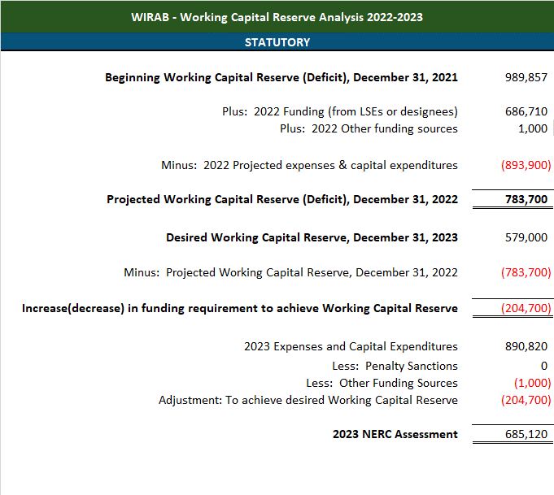 **Table B-1. Working Capital Reserve Analysis 2022 – 202****3**

# Table B-2. 2022 Budget with 2023 & 2024 Projections

WIRAB projects a 3.1% decrease to its annual budget in 2023 and a 3.4% increase in 2024. These decreases and increases reflect a decrease in indirect expenses and expected cost-of-living adjustments to personnel expenses for employees working in Denver, Colorado.



**Section C – Non-Statutory Activities**

2023 Business Plan and Budget

WIRAB does not engage in non-statutory activities.

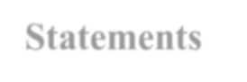

**Section D – Additional Consolidated Financial**

**Statements**

2023 Business Plan and Budget

# Statement of Financial Position

Table D-1 provides WIRAB’s Statement of Financial Position as of the following dates:

* As of June 30, 2021, per audit
* As of December 31, 2022, projected
* As of December 31, 2023, as budgeted

# Table D-1. Statement of Financial Position, Three-Year Comparison

# 

**Appendix A – Organization Chart**

2023 Business Plan and Budget

**The WIRAB Staff Organization Chart is shown below.**

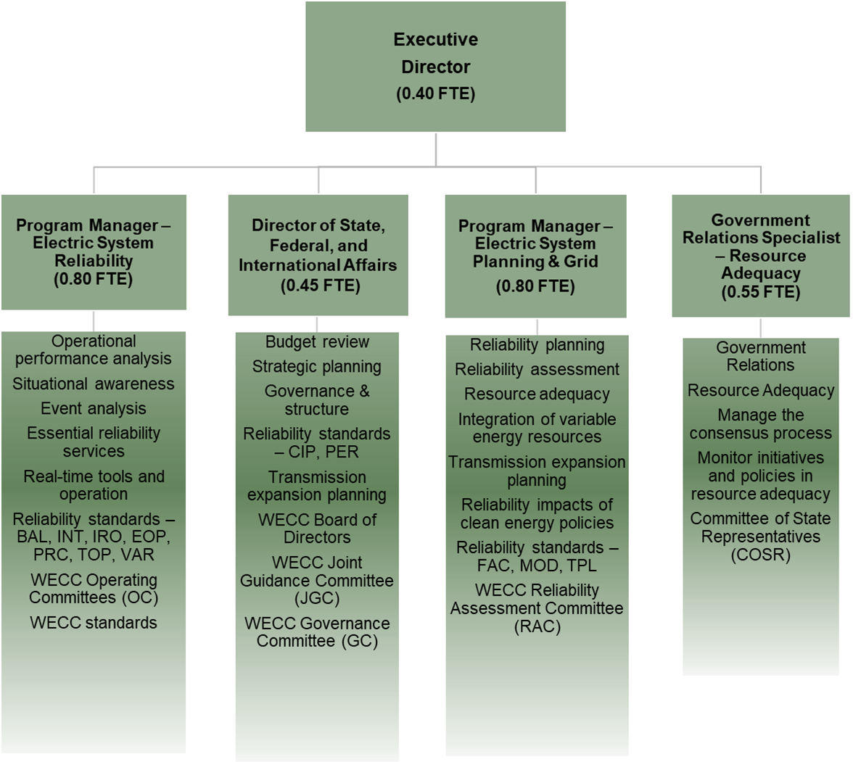

1. WECC has historically entered into an annual agreement with Comisión Reguladora de Energía; at this time of filing, this agreement remains under negotiation. The statutory funding assessments allocations will be updated when appropriate.
2. Order on Petition to Establish a Regional Advisory Body for the Western Interconnection, 116 FERC ¶ 61,061, Docket No. RR06-2-000, July 20, 2006.
3. Rules Concerning Certification of the Electric Reliability Organization; and Procedures for the Establishment, Approval, and Enforcement of Reliability Standards, Order 672, Docket RM05-30-000, Feb. 3, 2006, P. 228. “Each Regional Entity must submit its complete business plan, entire budget, and organizational chart to the ERO for it to submit to the Commission. The complete business plan and the entire budget will provide the Commission with necessary information about any non-statutory activities, the source of their funding, and whether the pursuit of such activities presents a conflict of interest for the Regional Entity. For a Cross-Border Regional Entity, this information will also inform the Commission as to what portion of the budget is expended upon activities within the United States.”